**EXP NO : 1**

**Commands:**

**1]** **DATE**

**date**

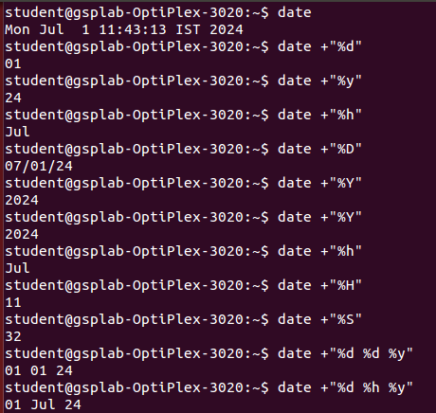

**2] CAL**

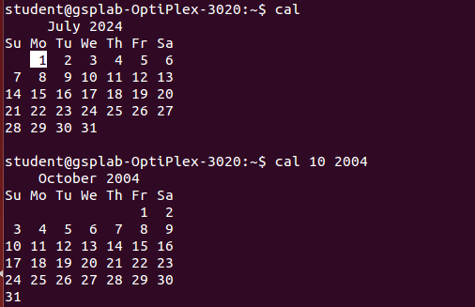

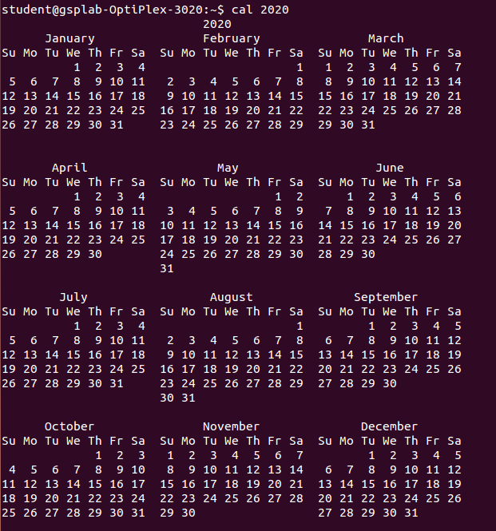

**3] WHO**

**Who**





**4] PS**

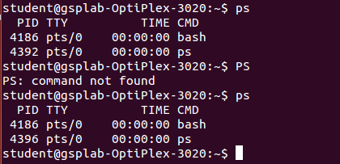

**5] LS**

**ls**

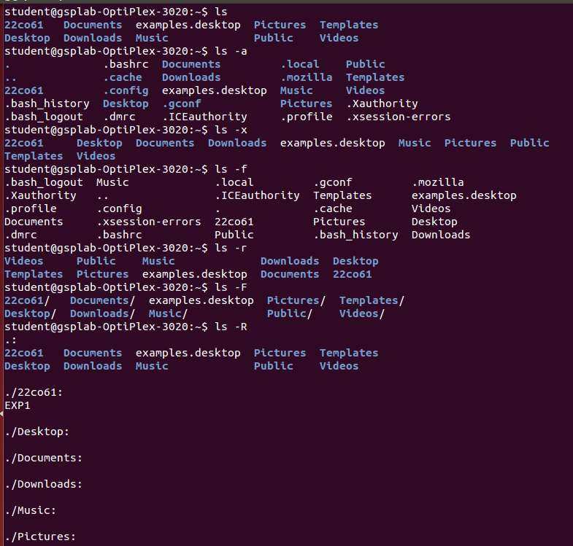

**6] WC**

**wc**

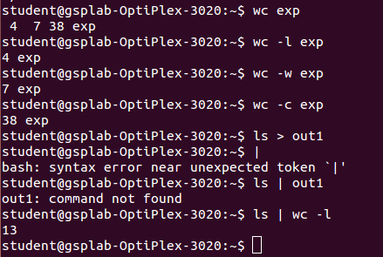

**7] METACHARACTER**

**ls > output_of_ls //takes the list of directories and puts in a file name given**

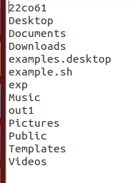



**8] CAT //used to open or create file**

**cat greating**

hello world

this is the 1st day of sem 5

good luck!

**cat > new_file_created_from_terminal**

to exit use Ctrl+d

**cat new_file_created_from_terminal**

to exit use Ctrl+d

**9] BC //open calculator**

**bc**

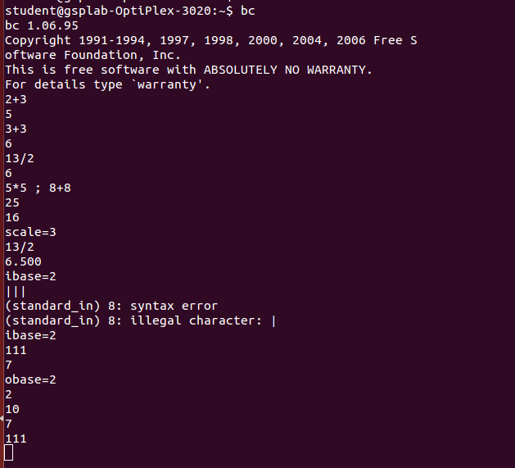

**10] MANUAL**

**man date**

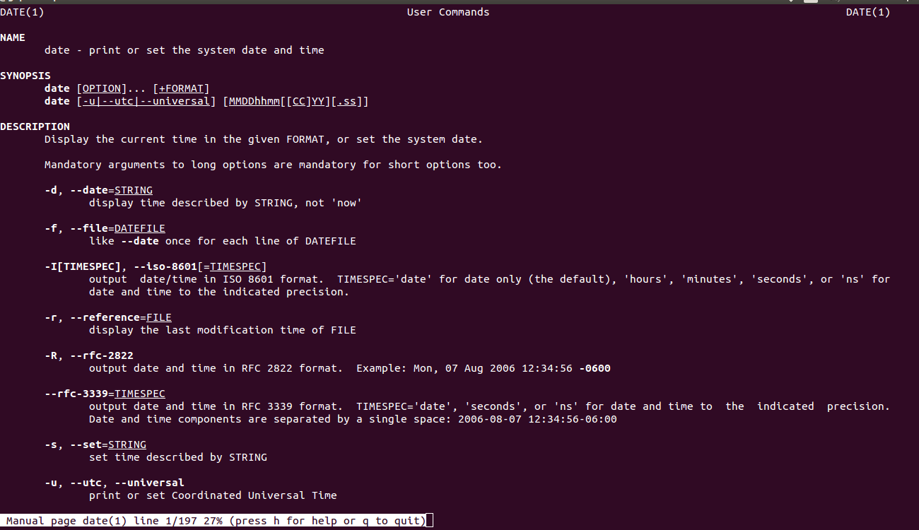

**11] ECHO**

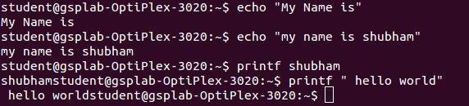

1. **echo "Today's date is `date +”%d %h %y” ‘**

**Today's date is 01 Jul 24**

**12] script //records the session**

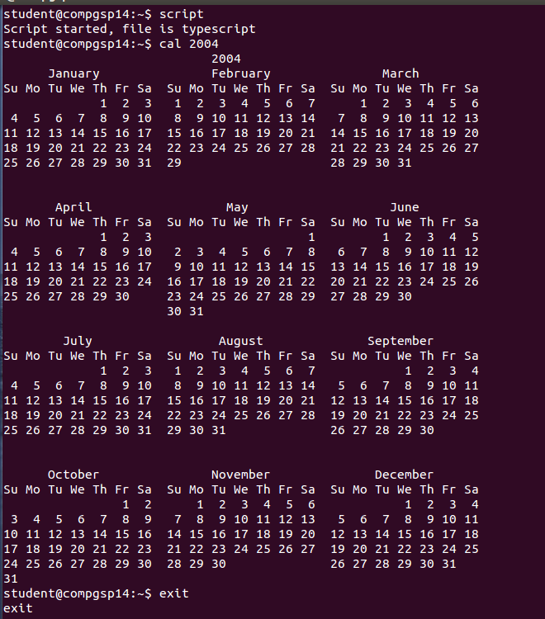

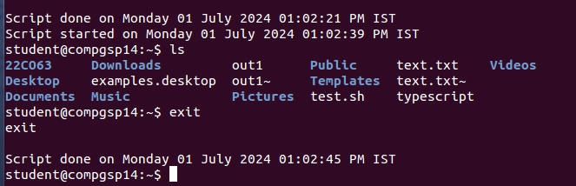

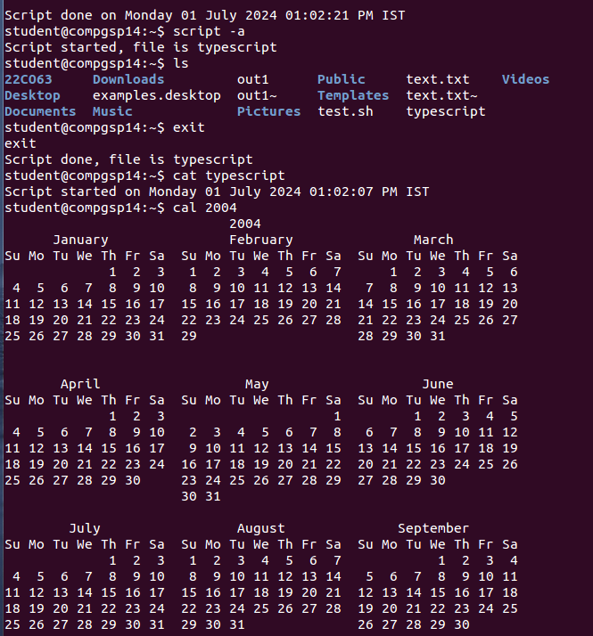

**13] Password**

**Changing password for student.**

**Current password:**

**Current Password:**

**passwd: Authentication token manipulation error**

**passwd: password unchanged**

**14] uname**

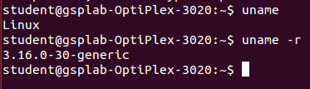

**15] tty**

C:\Users\user\Downloads\mkdir.png

**16] pwd //knowing the current path of where your working**

C:\Users\user\Downloads\rmdir.png

**17] mkdir**

**i) To create new folder**

comp-gsp-02@compgsp02-OptiPlex-3020:~$ mkdir Folder

comp-gsp-02@compgsp02-OptiPlex-3020:~$ ls

Desktop Downloads Music Pictures Templates

Documents Folder OS Public Videos

**ii) To create multiple folders**

comp-gsp-02@compgsp02-OptiPlex-3020:~$ mkdir wt cn

comp-gsp-02@compgsp02-OptiPlex-3020:~$ ls

cn Documents Folder OS Public Videos

Desktop Downloads Music Pictures Templates wt

**iii)To create folder inside folder**

comp-gsp-02@compgsp02-OptiPlex-3020:~$ mkdir dbms dbms/unit1 dbms/unit1/chapter1



**18] rmdir**

comp-gsp-02@compgsp02-OptiPlex-3020:~$ rmdir dbms/unit1/chapter1 dbms/unit1 dbms

comp-gsp-02@compgsp02-OptiPlex-3020:~$ ls dbms

ls: cannot access 'dbms': No such file or directory

**19] cd**



**20] cp (copy)**

comp-gsp-02@compgsp02-OptiPlex-3020:~$ cat > test1.txt

Hello World!

comp-gsp-02@compgsp02-OptiPlex-3020:~$ cat test1.txt

Hello World!

comp-gsp-02@compgsp02-OptiPlex-3020:~$ cp test1.txt test2.txt

**i) To copy into folder**

comp-gsp-02@compgsp02-OptiPlex-3020:~$ cp test1.txt test2.txt wt

comp-gsp-02@compgsp02-OptiPlex-3020:~$ ls wt

test1.txt test2.txt

**ii) To copy folder into folder**

comp-gsp-02@compgsp02-OptiPlex-3020:~$ cp -r f1 f2

comp-gsp-02@compgsp02-OptiPlex-3020:~$ ls f2

f1

**iii)To take permission to overwrite existing file**

comp-gsp-02@compgsp02-OptiPlex-3020:~$ cp -i test1.txt test2.txt

cp: overwrite 'test2.txt'? y

**21] rm (remove file)**

**i) To remove file**

comp-gsp-02@compgsp02-OptiPlex-3020:~$ rm file1.txt

comp-gsp-02@compgsp02-OptiPlex-3020:~$ ls file1.txt

ls: cannot access 'file1.txt': No such file or directory

**ii) To remove file from folder**

comp-gsp-02@compgsp02-OptiPlex-3020:~$ ls f1

test2.txt

comp-gsp-02@compgsp02-OptiPlex-3020:~$ rm f1/test2.txt

comp-gsp-02@compgsp02-OptiPlex-3020:~$ ls f1

comp-gsp-02@compgsp02-OptiPlex-3020:~$

**iii) To remove file with permission**

comp-gsp-02@compgsp02-OptiPlex-3020:~$ rm -i file1.txt

rm: remove regular file 'file1.txt'? y

comp-gsp-02@compgsp02-OptiPlex-3020:~$ ls file1.txt

ls: cannot access 'file1.txt': No such file or directory

**iv)To remove all files in the folder**

comp-gsp-02@compgsp02-OptiPlex-3020:~$ ls f2

test1.txt test2.txt

comp-gsp-02@compgsp02-OptiPlex-3020:~$ rm -r f2

comp-gsp-02@compgsp02-OptiPlex-3020:~$ ls f2

ls: cannot access 'f2': No such file or directory

**22] mv (To move files)**

**i) To rename file**

comp-gsp-02@compgsp02-OptiPlex-3020:~$ mv test2.txt new.txt

comp-gsp-02@compgsp02-OptiPlex-3020:~$ ls new.txt

new.txt

**ii) To move file to folder**

comp-gsp-02@compgsp02-OptiPlex-3020:~$ mv new.txt cn

comp-gsp-02@compgsp02-OptiPlex-3020:~$ ls cn

new.txt

**23] Wild Cards (Pattern matching)**

**i) * (Zero or more character)**

comp-gsp-02@compgsp02-OptiPlex-3020:~$ ls file*

file123.txt file12.txt file1.txt file2.txt file3.txt

**ii) ? (A single character)**

comp-gsp-02@compgsp02-OptiPlex-3020:~$ ls file?.txt

file1.txt file2.txt file3.txt

**iii) [ijk] (matches single character i,j or k)**

comp-gsp-02@compgsp02-OptiPlex-3020:~$ ls file[123].txt

file1.txt file2.txt file3.txt

**iv) [1-4] (It matches single character either 1,2,,3 or 4)**

comp-gsp-02@compgsp02-OptiPlex-3020:~$ ls file[1-4].txt

file1.txt file2.txt file3.txt

**v) [!ijk] (Matches single character other than i,j or k)**

comp-gsp-02@compgsp02-OptiPlex-3020:~$ ls file[!23].txt

file1.txt

**vi) [! 1-4] (Not of range)**

comp-gsp-02@compgsp02-OptiPlex-3020:~$ ls file[!1-2].txt

file3.txt

**viii) Pattern Matching**

i) Match all file name with the single character extension with single character extension but

not .c and .o

comp-gsp-02@compgsp02-OptiPlex-3020:~$ ls *.[!co]??

file123.txt file1.txt file3.txt

file12.txt file2.txt google-chrome-stable_current_amd64.deb

**ii) Match all file name doesn’t begin with character**

comp-gsp-02@compgsp02-OptiPlex-3020:~$ ls [!A-Za-z]*

18.txt

**24] od ( To read o and exe file)**

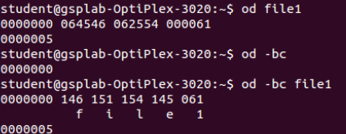

**25] cmp**

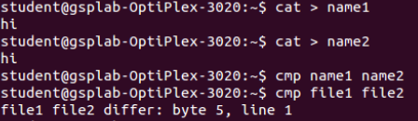

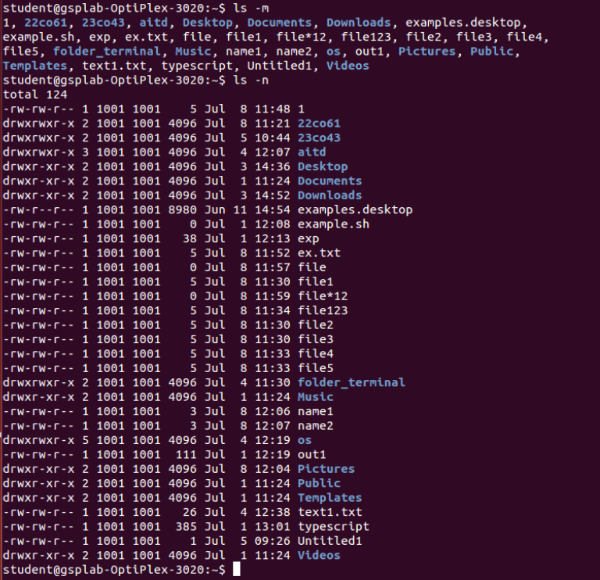

**26] chmod (To change permission read write)**

i) relative permission (what is told to be changed)

U - user + assigning permission

G - group - removing the permission

O - others w - write; read r; execution x

A - all

Q1) assuming the file name called file1 perform the following operations

Assign execution for user

Assign writing for group

Assign remove execution for others



Q2) on file2 change the following permissions

Assign read for all

Writing for owner and all

Execution for owner and others



Q3) on file1 assign following permissions

Reading and writing for user (6 - 110)

Writing execution for group owner

And only reading for others



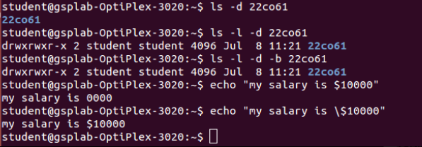

**27] Pr (paginating the file)**

student@compgsp14:~$ pr emp.txt

2233|a.k. shukla|g.m.|sales|12/12/52|6000

9876|jai sharma|director|production|03/12/50|7000

5678|sumit chakrobarty|d.g.m|marketing|04/19/43|6000

2365|barun sengupta|director|personnel|05/11/47|7800

5423|n.k. gupta|chairman|admin|08/30/56|5400

1006|chanchal sanghvi|director|sales|09/03/38|6700

6213|karuna ganguly|g.m.|accounts|06/05/62|6300

1265|s.n. dasgupta|manager|sales|09/12/63|5600

4290|jayant Chodhury|executive|production|09/07/50|6000

2476|anil aggarwal|manager|sales|05/01/59|5000

6521|lalit chowdury|director|marketing|09/26/45|8200

3212|shyam saksena|d.g.m|accounts|12/12/55|6000

3564|sudhir Agarwal|executive|personnel|07/06/47|8000

2345|j.b. saxena|g.m.|marketing|03/12/45|8000

0110|v.k. agrawal |g.m.|marketing|12/31/40|9000 ( reading for printing)

**28] Head ( print 2st 10 line for printing )**

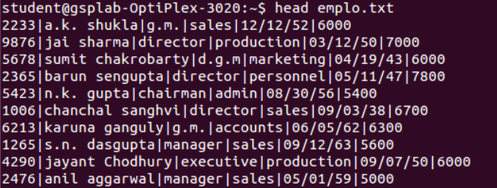

**i) head -n 3 ( To print only first 3 lines )**

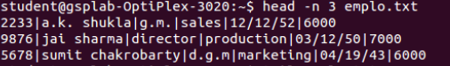

**29] Tail ( print last 10 line of file )**

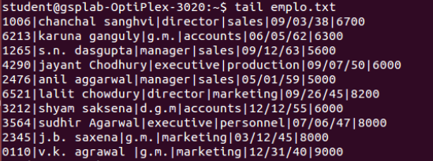

**i] tail –n 4**

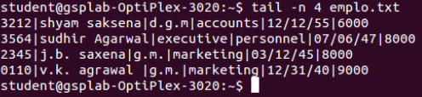

**ii] tail –n 1**



**iii] student@compgsp14:~$ tail +8 emp.txt**

1265|s.n. dasgupta|manager|sales|09/12/63|5600

4290|jayant Chodhury|executive|production|09/07/50|6000

2476|anil aggarwal|manager|sales|05/01/59|5000

6521|lalit chowdury|director|marketing|09/26/45|8200

3212|shyam saksena|d.g.m|accounts|12/12/55|6000

3564|sudhir Agarwal|executive|personnel|07/06/47|8000

2345|j.b. saxena|g.m.|marketing|03/12/45|8000

0110|v.k. agrawal |g.m.|marketing|12/31/40|9000

**30] Sort**

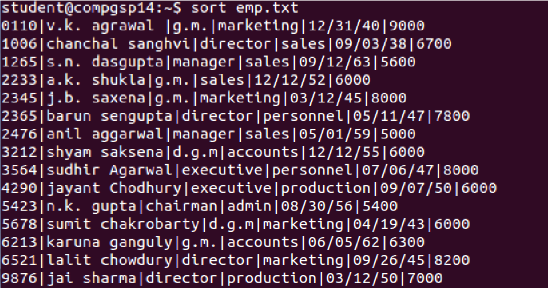

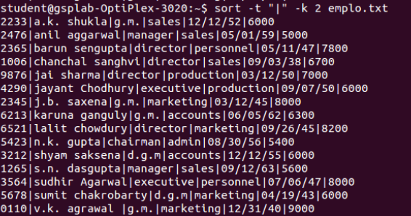

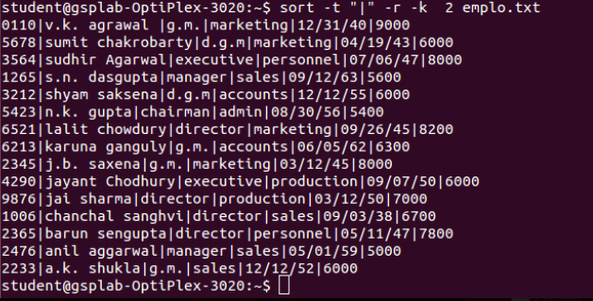

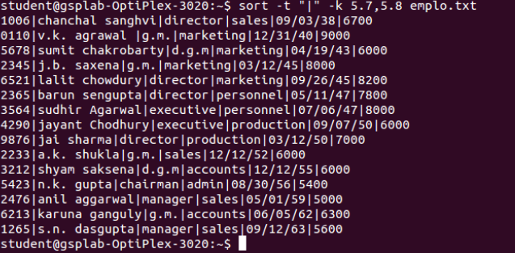

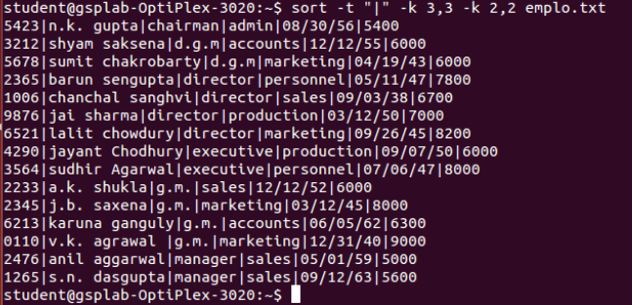

**31] Cut-c**

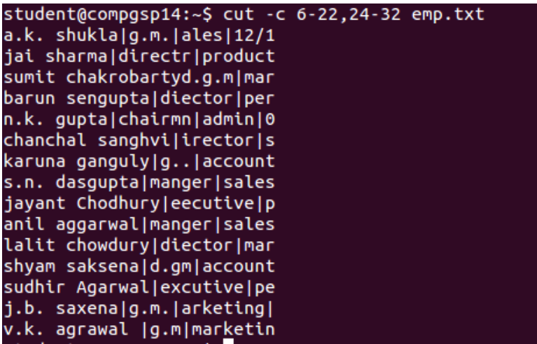

**32] Sorting Number**

student@compgsp006-OptiPlex-3020:~$ cat note1.txt

16

15

11

14

14

10

9

6

7

7

17

1

3

4

**student@compgsp006-OptiPlex-3020:~$ sort –n note1.txt**

1

3

4

6

7

7

9

10

11

14

14

15

16

17

**student@compgsp006-OptiPlex-3020:~$ cat > note2 .txt**

8

5

6

1

9

4

7

**student@compgsp006-OptiPlex-3020:~$ sort -o new_sort note2 .txt**

**student@compgsp006-OptiPlex-3020:~$ cat new_sort**

**1**

**4**

**5**

**6**

**7**

**8**

**9**

**33] Uniq**

student@compgsp006-OptiPlex-3020:~$ cat > note3 .txt

1

2

3

4

5

6

7

8

9

10

**student@compgsp006-OptiPlex-3020:~$ uniq –u note3 .txt**

1

2

3

4

5

6

7

8

9

10

**student@compgsp006-OptiPlex-3020:~$ cat > note3 .txt**

1

2

2

3

4

4

5

6

7

7

7

8

9

10

**student@compgsp006-OptiPlex-3020:~$ uniq -u note3 .txt**

1

3

5

6

8

9

10

**student@compgsp006-OptiPlex-3020:~$ uniq –c note3.txt**

1 1

2 2

1 3

2 4

1 5

1 6

3 7

1 8

1 9

1 10

**34] Comm ( To find common context in file)**

student@compgsp006-OptiPlex-3020:~$ cat > note_4. txt

**100**

**50**

**80**

student@compgsp006-OptiPlex-3020:~$ cat > note_5. txt

**100**

**50**

**80**

**60**

**30**

student@compgsp006-OptiPlex-3020:~$ comm note_4. txt note_5.txt

**100**

**50**

**80**

**60**

Comm : file 2 is not sorted order

**30**

**35] Tr (translating character)**

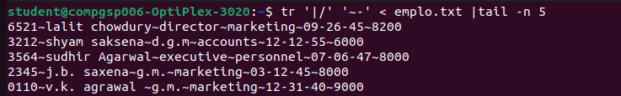

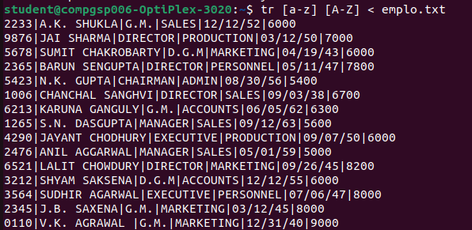

**36] Grep**

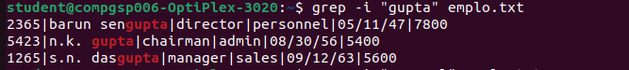

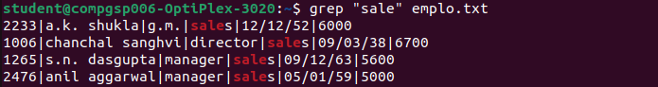





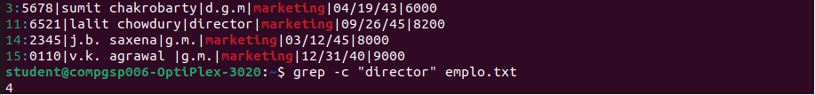

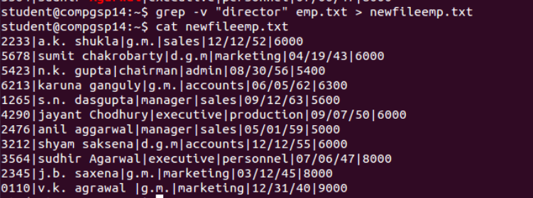

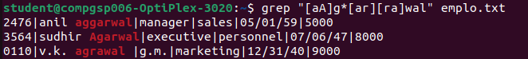



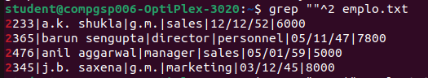

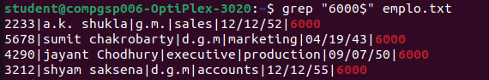

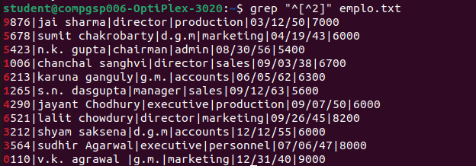

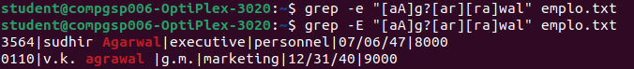

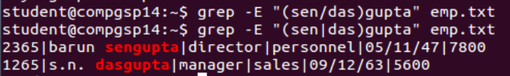

**37] Touch**

student@compgsp006-OptiPlex-3020:~$ touch note1

student@compgsp006-OptiPlex-3020:~$ ls –l note1

-rw-rw-r-- 1 student student 0 Jul 11 12:39 note1

**38] Tee**

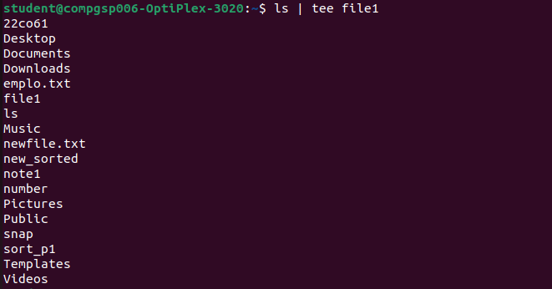

**39] Getfacl**

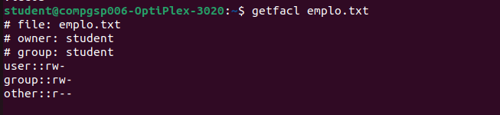

**40] Free**

